HTML5 & CSS3:
New Markup & Styles for the Emerging Web

Jason A. Clark
Head of Digital Access and Web Services
Montana State University Library
jaclark@montana.edu
twitter.com/jaclark

The HTML 5 specification

The HTML 5 specification (http://dev.w3.org/html5/spec/Overview.html) goes into great detail to list the multitude of additions and extensions. Here's a quick distillation of some of the top level features of the standard.

- Semantic and Functional Markup
  - New markup tags such as header, footer, nav, section, article, aside, figure, and the contenteditable attribute allow for better divisions of content and provide meaningful human and machine readable tags.
- Smart Forms
  - New field types like email and date allow search boxes and text inputs access to better tools for validating and interacting with user requests.
- Geolocation
  - Part of the location API maintained by World Wide Web Consortium (w3c) which does what you would expect: allows your browser (and therefore, your web app) to track a user's physical location.
- Native Video and Audio
  - Simple markup that allows embedding, streaming, and playback of video and audio. Markup like <video src="turkish.mp4" controls></video> will create a video player right in your browser without the need for a plugin.
- Offline Storage
  - Think of this like "Cookies on Steroids". This new functionality enables full, persistent database-like storage within the browser. You can take your apps offline and still be making edits and changes to your data.
- Canvas Element
  - Developers can create graphics, images, games, and visualizations by using the <canvas> tag to draw elements into the browser using simple programming and markup. Again, there is no need for a plugin.
- Drag and Drop, Web Workers
  - A focus on common user interface conventions such as drag and drop as well as threaded processing of data behind the scenes with Web Workers make it easy to build common web apps like real-time chat into your site.

New Semantic Markup Elements
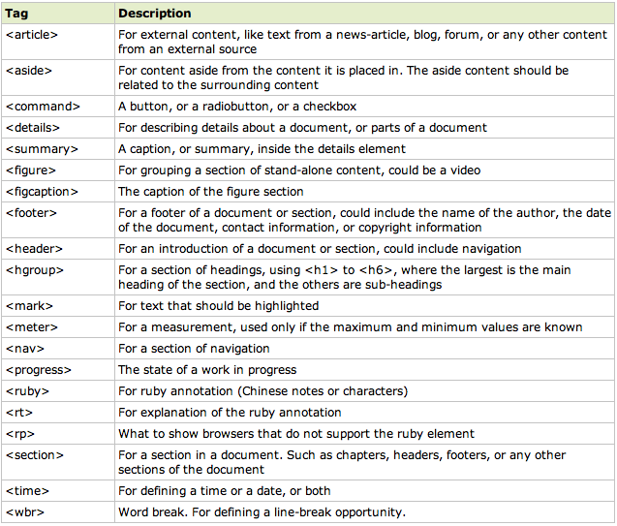

New Media Elements
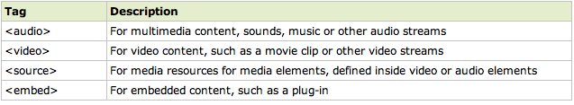

The Canvas Element

New Form Elements
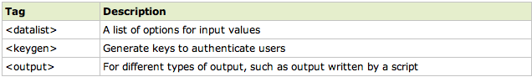

New Form Input Elements
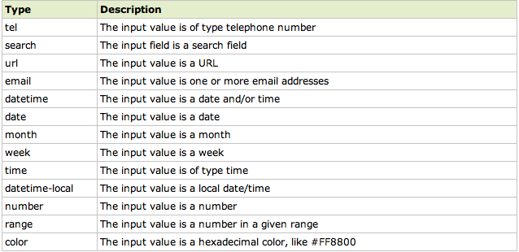

A Minimal HTML5 Boilerplate

<!DOCTYPE html>
<html lang="en">
<head>
<meta charset="utf-8" />
<title>HTML5 boilerplate - future proof for older browsers</title>
<link rel="stylesheet" href="style.css" />
<!--[if IE]>
<script src="http://html5shiv.googlecode.com/svn/trunk/html5.js"></script>
<![endif]-->
</head>
<body>
<h1>HTML5 boilerplate</h1>
<!--more page content-->
</body>
</html>

The CSS3 specification

The CSS3 specification contains several new properties and selectors, and many of them have already been implemented in modern browsers. I’m highlighting a few of these new features, but this list is just a start. A complete CSS3 reference is available at www.w3schools.com/css3/css3_reference.asp

CSS3 Font Properties
Property | Description
@font-face | A rule that allows websites to download and use fonts other than the "web-safe" fonts
font-size-adjust | Preserves the readability of text when font fallback occurs
font-stretch | Selects a normal, condensed, or expanded face from a font family

CSS3 Border Properties
Property | Description
border-bottom-left-radius | Defines the shape of the border of the bottom-left corner
border-bottom-right-radius | Defines the shape of the border of the bottom-right corner
border-image | A shorthand property for setting all the border-image-* properties
border-image-outset | Specifies the amount by which the border image area extends beyond the border box
border-image-repeat | Specifies whether the image-border should be repeated, rounded or stretched
border-image-slice | Specifies the inward offsets of the image-border
border-image-source | Specifies an image to be used as a border
border-image-width | Specifies the widths of the image-border
border-radius | A shorthand property for setting all the four border-*-radius properties
border-top-left-radius | Defines the shape of the border of the top-left corner
border-top-right-radius | Defines the shape of the border of the top-right corner
box-shadow | Attaches one or more drop-shadows to the box

CSS3 Text Properties
Property | Description
hanging-punctuation | Specifies whether a punctuation character may be placed outside the line box
punctuation-trim | Specifies whether a punctuation character should be trimmed
text-align-last | Describes how the last line of a block or a line right before a forced line break is aligned when text-align is "justify"
text-emphasis | Applies emphasis marks, and the foreground color of the emphasis marks, to the element's text
text-justify | Specifies the justification method used when text-align is "justify"
text-outline | Specifies a text outline
text-overflow | Specifies what should happen when text overflows the containing element
text-shadow | Adds shadow to text
text-wrap | Specifies line breaking rules for text
word-break | Specifies line breaking rules for non-CJK scripts
word-wrap | Allows long, unbreakable words to be broken and wrap to the next line

CSS3 Color Properties
Property | Description
color-profile | Permits the specification of a source color profile other than the default
Opacity | Sets the opacity level for an element
rendering-intent | Permits the specification of a color profile rendering intent other than the default
CSS3 Transition Properties
Property | Description
transition | A shorthand property for setting the four transition properties
transition-property | Specifies the name of the CSS property the transition effect is for
transition-duration | Specifies how many seconds or milliseconds a transition effect takes to complete
transition-timing-function | Specifies the speed curve of the transition effect
transition-delay | Specifies when the transition effect will start

CSS3 2D/3D Transform Properties
Property | Description
transform | Applies a 2D or 3D transformation to an element
transform-origin | Allows you to change the position on transformed elements
transform-style | Specifies how nested elements are rendered in 3D space
perspective | Specifies the perspective on how 3D elements are viewed
perspective-origin | Specifies the bottom position of 3D elements
backface-visibility | Defines whether or not an element should be visible when not facing the screen

CSS3 Hyperlink Properties
Property | Description
target | A shorthand property for setting the target-name, target-new, and target-position properties
target-name | Specifies where to open links (target destination)
target-new | Specifies whether new destination links should open in a new window or in a new tab of an existing window
target-position | Specifies where new destination links should be placed
CSS3 Grid Properties
Property | Description
grid-columns | Specifies the width of each column in a grid
grid-rows | Specifies the height of each column in a grid

CSS3 Multi-column Properties
Property | Description
column-count | Specifies the number of columns an element should be divided into
column-fill | Specifies how to fill columns
column-gap | Specifies the gap between the columns
column-rule | A shorthand property for setting all the column-rule-* properties
column-rule-color | Specifies the color of the rule between columns
column-rule-style | Specifies the style of the rule between columns
column-rule-width | Specifies the width of the rule between columns
column-span | Specifies how many columns an element should span across
column-width | Specifies the width of the columns
columns | A shorthand property for setting column-width and column-count

CSS3 Example Styles

@font-face
{
font-family: myFirstFont;
src: url('Sansation_Light.ttf')
,url('Sansation_Light.eot') format("opentype"); /* IE */
}

div.main
{
font-family:myFirstFont;
border:2px solid;
-moz-border-radius:25px; /* Firefox */
-webkit-border-radius:25px; /* Safari and Chrome */
border-radius:25px;
-moz-box-shadow: 10px 10px 5px #888888; /* Firefox */
-webkit-box-shadow: 10px 10px 5px #888888; /* Safari and Chrome */
box-shadow: 10px 10px 5px #888888;
}

div.main ul#animateList li a
{
cursor: pointer;
-webkit-transition: padding-left 250ms ease-out;
-moz-transition: padding-left 250ms ease-out;
/* trans pattern: property duration timingMethod delay */
}

div.main ul#animateList li a:hover
{
padding-left: 20px;
}

CSS3 Media Query Example for Targeting Mobile Devices

@media only screen and (device-width: 768px) and (orientation: landscape) {
/* rules for iPad in landscape orientation */
}
@media only screen and (min-device-width: 320px) and (max-device-width: 480px) {
/* iPhone, Android rules here */
}

Further Reading and Resources

Dive into HTML 5
http://diveintohtml5.org/

HTML 5 Demos and Examples (from Remy Sharp)
http://html5demos.com/

HTML5ROCKS
http://www.html5rocks.com/

HTML5 Tag Reference (W3Schools)
w3schools.com/html5/html5_reference.asp

Cross Browser Support Tables
www.findmebyip.com/litmus/

HTML5 Doctor
html5doctor.com

CSS3 Previews (CSS3.info)
www.css3.info/preview/

HTML5 & CSS3 Cheat Sheets
webresourcesdepot.com/html-5-and-css3-cheat-sheets-collection/

HTML5 Boilerplate
http://html5boilerplate.com/

Modernizr
http://www.modernizr.com/

